# MSLC Online Tutoring-Student Instructions

## Accessing the MSLC Zoom Tutor Room for Drop-In

MSLC tutoring link: <https://go.osu.edu/mathtutoring>

You must login to Zoom with your OSU account to access the tutor room. General Instructions for Accessing OSU Zoom and signing in with OSU account: <https://resourcecenter.odee.osu.edu/carmenzoom/getting-started-carmenzoom>

## Communicating in Zoom

This document will provide the basics of Zoom communication tools, but you can find in-depth information on Zoom audio/video/screen sharing/shared whiteboards here: <https://support.zoom.us/hc/en-us/categories/201137166>

### Audio and Video

When you first enter Zoom, it will usually ask if you want to use your computer to connect to audio and video, select yes. When you enter the Zoom room, you will see the microphone and video icons. A red slash means you are not connected with audio/video. Clicking on the icon will enable audio/video. The up arrows also open menus to adjust settings and select alternative speakers/microphone/camera. With the up arrow on video, you can also select an alternative background, however, if you plan to share written work by holding up a piece of paper or whiteboard, the alternative background may cut it out of view.



When working with the tutor, you will either want to share a video/picture/or screen share both the problem you are working on as well as any work you have so far.

### Screen share/Shared Whiteboard

To Screen share from a Desktop, select on the Screen share icon in Zoom menu. Then select the screen you want to share (or whiteboard), then select “Share”.

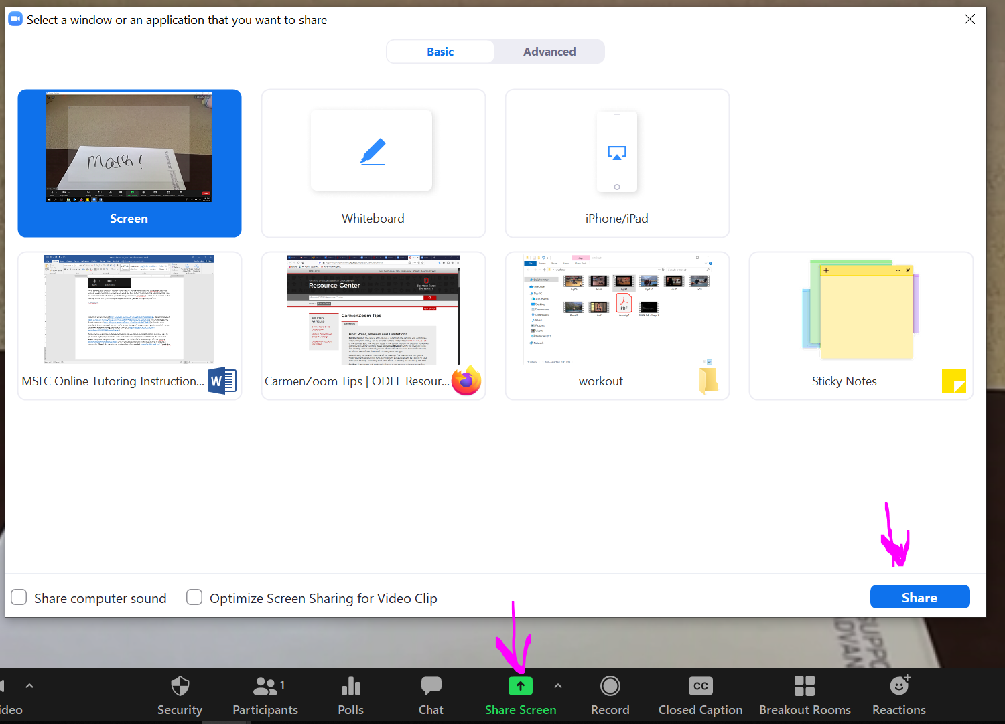

To share from an iPad or iphone, you may have to adjust your settings (<https://support.zoom.us/hc/en-us/articles/115005890803-iOS-Screen-Sharing>). However, generally for iOS or Android, you can click on the screen share icon and then select to share your screen or choose the whiteboard.

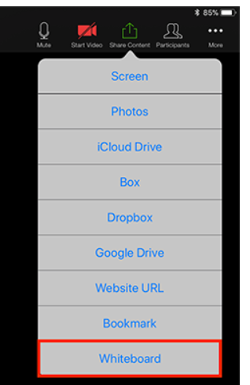

### Annotating:

Accessing annotation tools if you are viewing a shared screen:

On a desktop select view options and then annotate.

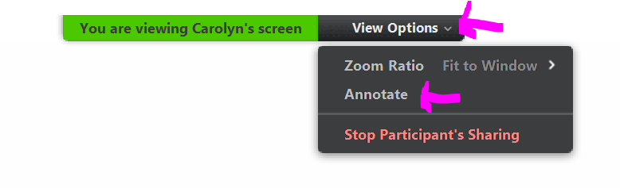

On a tablet/phone, select the pen with a circle around it near the bottom of the screen:

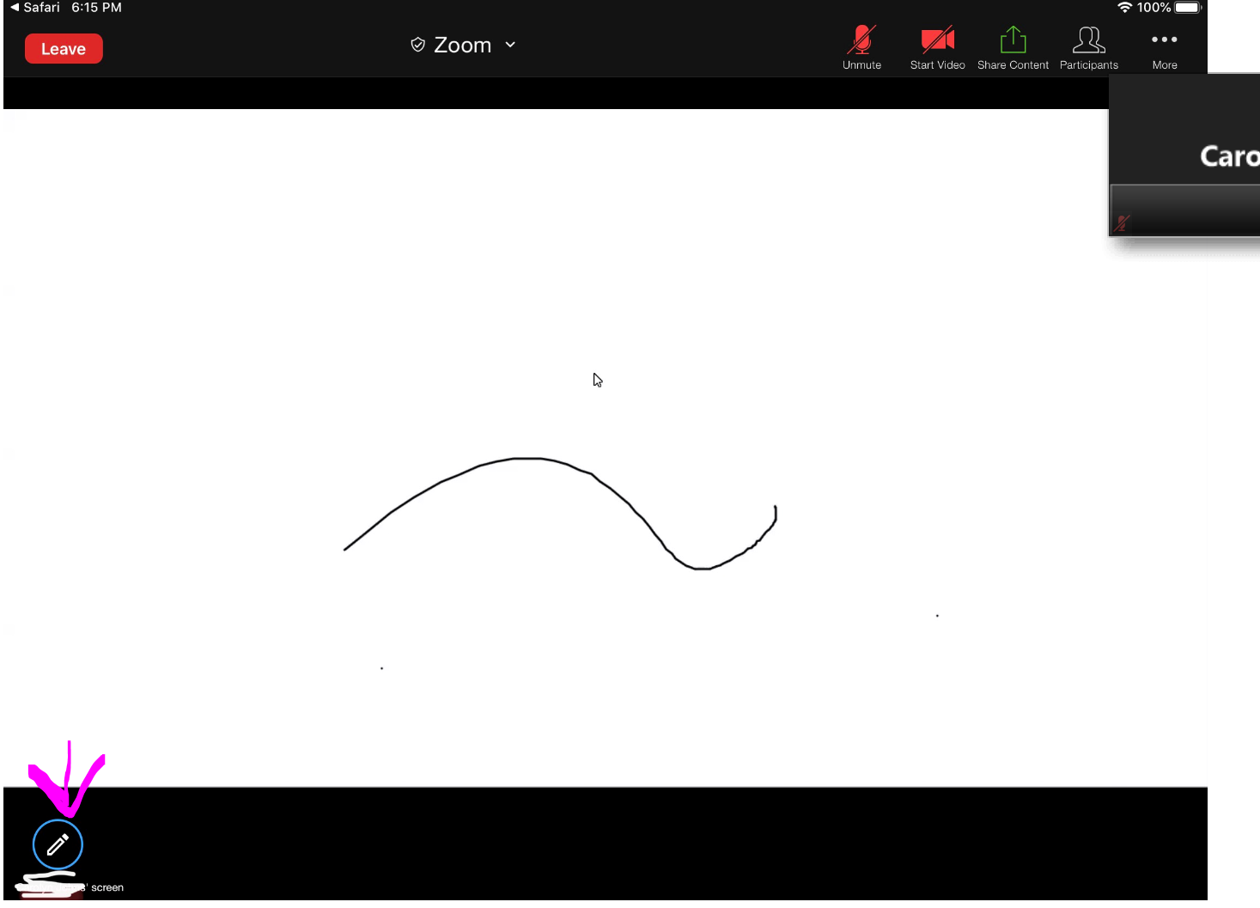

## Sharing written work without an iPad/digital writing

Throughout the tutoring session, you can also continue to video share yourself writing on paper or screen share writing on your screen so the tutoring can see how you are progressing as the two of you talk through the problem.

*Note if you are using your front camera to share written work, you may need to turn off the mirror image in the video settings.

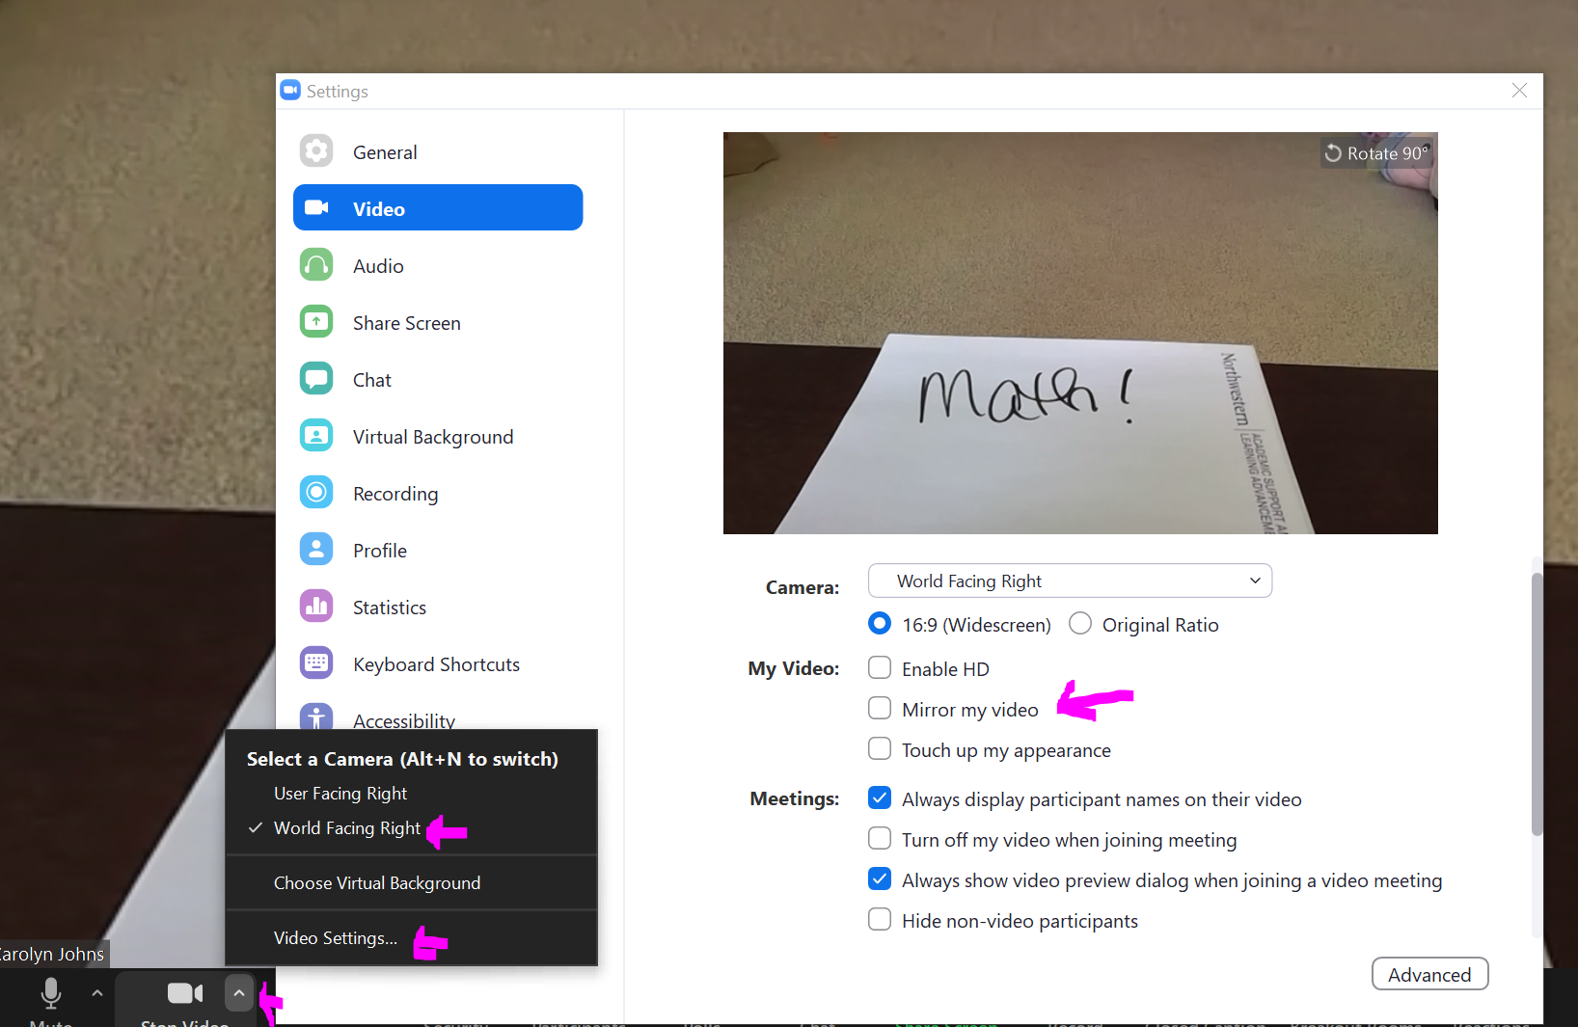

You can also access Zoom on your phone if that is your only camera available. To focus your phone on your paper, create a stack of books beside your paper and then hang your phone camera off the edge so it’s focused on your paper. Make sure you have your volume on speaker turned up, so you know when the tutor is trying to communicate with you!