Math 1151 Workshop 0: Refresh and Tips

Mathematics and Statistics Learning Center (mslc.osu.edu/tutoring)

## Problem 1: Try on your own, write down any questions, then look for answers

Consider the following graph of a function $f$:

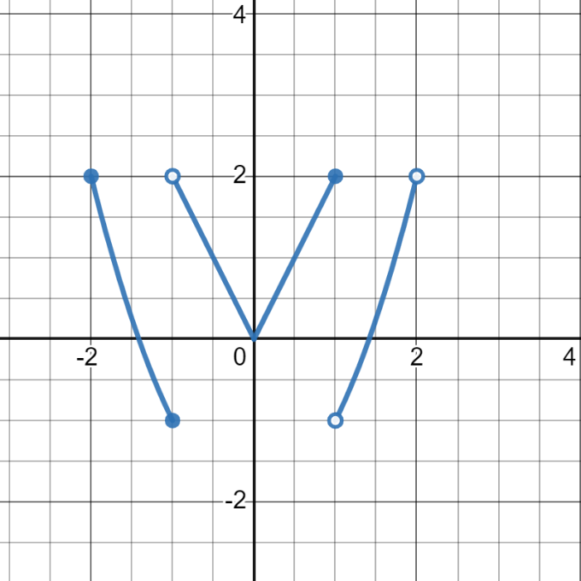

1. What is the domain of the function $f$?
2. What is the range of the function $f$?
3. What is the $y$-intercept of the graph?
4. What is $f\left(-1\right)$?
5. Solve the equation $f\left(x\right)=2$.
6. Is the function $f$ odd, even, or neither?
7. List the intervals where $f$ is increasing.
8. List the intervals where $f$ is decreasing.
9. Is the function $f$ invertible?
10. Give an interval where $f$ is one-to-one.

## Problem 2: Reflect on the problem after finishing: why did I ask it?

Draw a graph below of a function $f$ with the following properties.

1. The domain of $f$ is $\left[-4,3\right)$.
2. The range of $f$ is $\left[-3,3\right)$.
3. The $y$-intercept of the graph of $f$ is $\left(0,0\right)$.
$f\left(-1\right) = 2$

4. $f$ is increasing on the interval $\left(-3,-2\right)$.
5. $f$ is decreasing on the interval $\left(0,1\right)$.
6. $f$ is one-to-one on the interval $\left(2,3\right)$.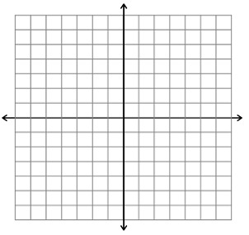

## Problem 3: Use previous parts of the problem to help

Determine the domain of the function $f$. Recall that an expression is undefined if its denominator is 0, it has a negative underneath an even root, or the argument of a logarithm is non-positive.

$f\left(x\right)=\frac{x}{x+2}$

$f\left(x\right)=\sqrt{1-x}$

$f\left(x\right)=\log\left(7x\right)$

$f\left(x\right)=\frac{2}{x^{2}-4}$

$f\left(x\right)=\frac{\sqrt{1-x}}{x+2}$

$f\left(x\right)=\frac{x}{\sqrt{1-x}}$

$f\left(x\right)=\frac{1}{\log\left(7x\right)}$

## Problem 4: Use Desmos to find the answers and then work in groups to justify your answers without graphing

Evaluate the following:

$\ln\left(e^{-5}\right)$

$e^{\ln\left(-5\right)}$

$\sqrt{4^{2}}$

$\sqrt{{\left(-4\right)}^{2}}$

Are any of the results surprising? Can you explain them? Explanation is a key skill we want you to learn in Calc 1.

## Problem 5: Explain what you found to a partner and come to an agreement

Recall the following logarithm rules:

$\log_{b}\left(xy\right)=\log_{b}\left(x\right)+\log_{b}\left(y\right)$

$\log_{b}\left(x/y\right)=\log_{b}\left(x\right)-\log_{b}\left(y\right)$

$\log_{b}\left(x^{p}\right)=p\log_{b}\left(x\right)$

Combine the following logarithms into one logarithm with coefficient 1.

$$\log\left(x\right)-\frac{1}{2}\log\left(y\right)+3\log\left(z\right)$$

Expand the following logarithm as much as possible. Try to have the inputs to the logarithms be as simple as possible.

$$\log\left(\frac{x^{2}\sqrt{y}}{z^{3}}\right)$$