Math 1151 Workshop 0: Refresh and Tips
Mathematics and Statistics Learning Center (mslc.osu.edu/tutoring)

Problem 1: Try on your own, write down any questions, then look for answers

Consider the following graph of a function $f$:
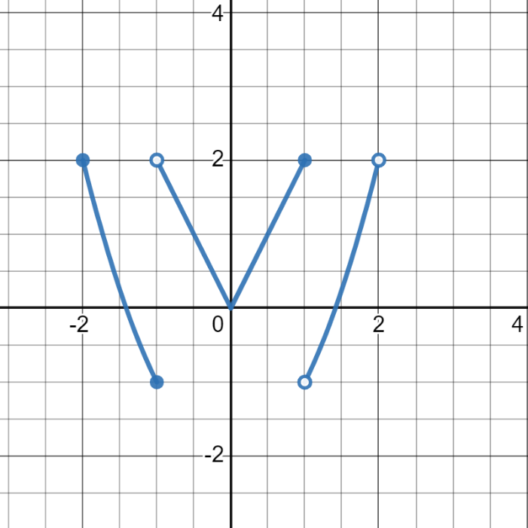

- What is the domain of the function $f$?
- What is the range of the function $f$?
- What is the $y$-intercept of the graph?
- What is $f\left(-1\right)$?
- Solve the equation $f\left(x\right)=2$.
- Is the function $f$ odd, even, or neither?
- List the intervals where $f$ is increasing.
- List the intervals where $f$ is decreasing.
- Is the function $f$ invertible?
- Give an interval where $f$ is one-to-one.

Problem 2: Reflect on the problem after finishing: why did I ask it?
Draw a graph below of a function $f$ with the following properties.
- The domain of $f$ is $\left[-4,3\right)$.
- The range of $f$ is $\left[-3,3\right)$.
- The $y$-intercept of the graph of $f$ is $\left(0,0\right)$.
- $f\left(-1\right) = 2$
- $f$ is increasing on the interval $\left(-3,-2\right)$.
- $f$ is decreasing on the interval $\left(0,1\right)$.
- $f$ is one-to-one on the interval $\left(2,3\right)$.
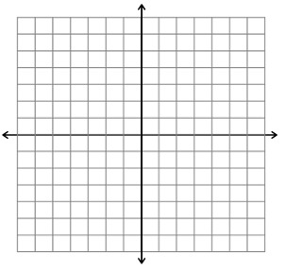

Problem 3: Use previous parts of the problem to help
Determine the domain of the function $f$. Recall that an expression is undefined if its denominator is 0, it has a negative underneath an even root, or the argument of a logarithm is non-positive.
- $f\left(x\right)=\frac{x}{x+2}$
- $f\left(x\right)=\sqrt{1-x}$
- $f\left(x\right)=\log\left(7x\right)$
- $f\left(x\right)=\frac{2}{x^{2}-4}$
- $f\left(x\right)=\frac{\sqrt{1-x}}{x+2}$
- $f\left(x\right)=\frac{x}{\sqrt{1-x}}$
- $f\left(x\right)=\frac{1}{\log\left(7x\right)}$

Problem 4: Use Desmos to find the answers and then work in groups to justify your answers without graphing
Evaluate the following:
- $\ln\left(e^{-5}\right)$
- $e^{\ln\left(-5\right)}$
- $\sqrt{4^{2}}$
- $\sqrt{{\left(-4\right)}^{2}}$
Are any of the results surprising? Can you explain them? Explanation is a key skill we want you to learn in Calc 1.

Problem 5: Explain what you found to a partner and come to an agreement
Recall the following logarithm rules:
- $\log_{b}\left(xy\right)=\log_{b}\left(x\right)+\log_{b}\left(y\right)$
- $\log_{b}\left(x/y\right)=\log_{b}\left(x\right)-\log_{b}\left(y\right)$
- $\log_{b}\left(x^{p}\right)=p\log_{b}\left(x\right)$
Combine the following logarithms into one logarithm with coefficient 1.
$$\log\left(x\right)-\frac{1}{2}\log\left(y\right)+3\log\left(z\right)$$

Expand the following logarithm as much as possible. Try to have the inputs to the logarithms be as simple as possible.
$$\log\left(\frac{x^{2}\sqrt{y}}{z^{3}}\right)$$

